The use case described in these diagrams is a cash withdrawal transaction at an ATM. Both the activity and sequence diagrams outline the process steps: the user inserts a card – the ATM requests a PIN – the user enters the PIN – the ATM forwards the PIN to the bank – the bank verifies it and responds with the status – the ATM then asks for the withdrawal amount – the user enters the amount – and finally the ATM dispenses the cash. While this captures the basic workflow – the design is overly simplistic and misses several key features. It does not include an option to eject the card and end the transaction if the user decides not to withdraw money – nor does it provide an initial menu with choices such as “Display Balance” – “Withdraw” – or “Exit.” Additionally – it lacks a prompt asking from which account (checking – savings – etc.) the funds should be withdrawn. These omissions limit both functionality and user experience – and addressing them would make the design more complete and realistic.
Actually there is a lot of feature missing, some of what I added to my UML:
- PIN verification first – ensures security before any menu or account info is shown.
- Language selection (English/Spanish) – improves accessibility right after PIN verification.
- Initial menu (Balance / Withdraw / Exit) – gives users clear choices at the start.
- Balance inquiry flow – bank sends account info and balance, user can view it, then decide to withdraw or exit.
- Account selection (Checking / Savings) – allows users to choose which account to withdraw from.
- Funds availability check – validates whether the requested amount can be dispensed.
- Retry loop for incorrect amounts – lets users enter a new amount, check balance, or exit instead of forcing termination.
- Receipt options (Print / Text / Email / None) – modernizes the ATM experience and reduces paper waste.
- Card ejection at every end path – ensures security and consistency, preventing forgotten cards.
[Start]
↓
[Insert Card]
↓
[Request PIN]
↓
[Verify PIN with Bank]
↓
[Select Language: English / Spanish]
↓
[Display Menu: Balance / Withdraw / Exit]
├──> [Balance Selected]
│ ↓
│ [Bank Sends Account Info + Balance]
│ ↓
│ [Display Balance]
│ ↓
│ [Decision: Withdraw or Exit]
│ ├──> [Withdraw Flow]
│ └──> [Eject Card] → [End]
│
├──> [Withdraw Selected]
│ ↓
│ [Bank Sends Account Info + Balance]
│ ↓
│ [Select Account: Checking / Savings]
│ ↓
│ [Enter Amount]
│ ↓
│ [Check Funds Availability]
│ ├──> [Funds Available] → [Dispense Cash] → [Receipt Options] → [Eject Card] → [End]
│ └──> [Funds Not Available] → [Display Error Message]
│ ↓
│ [Retry? Enter New Amount / Check Balance / Exit]
│ ├──> [Enter New Amount] → loop back to [Check Funds Availability]
│ ├──> [Check Balance] → back to Balance flow (Withdraw or Exit)
│ └──> [Eject Card] → [End]
│
└──> [Exit Selected]
↓
[Eject Card] → [End]
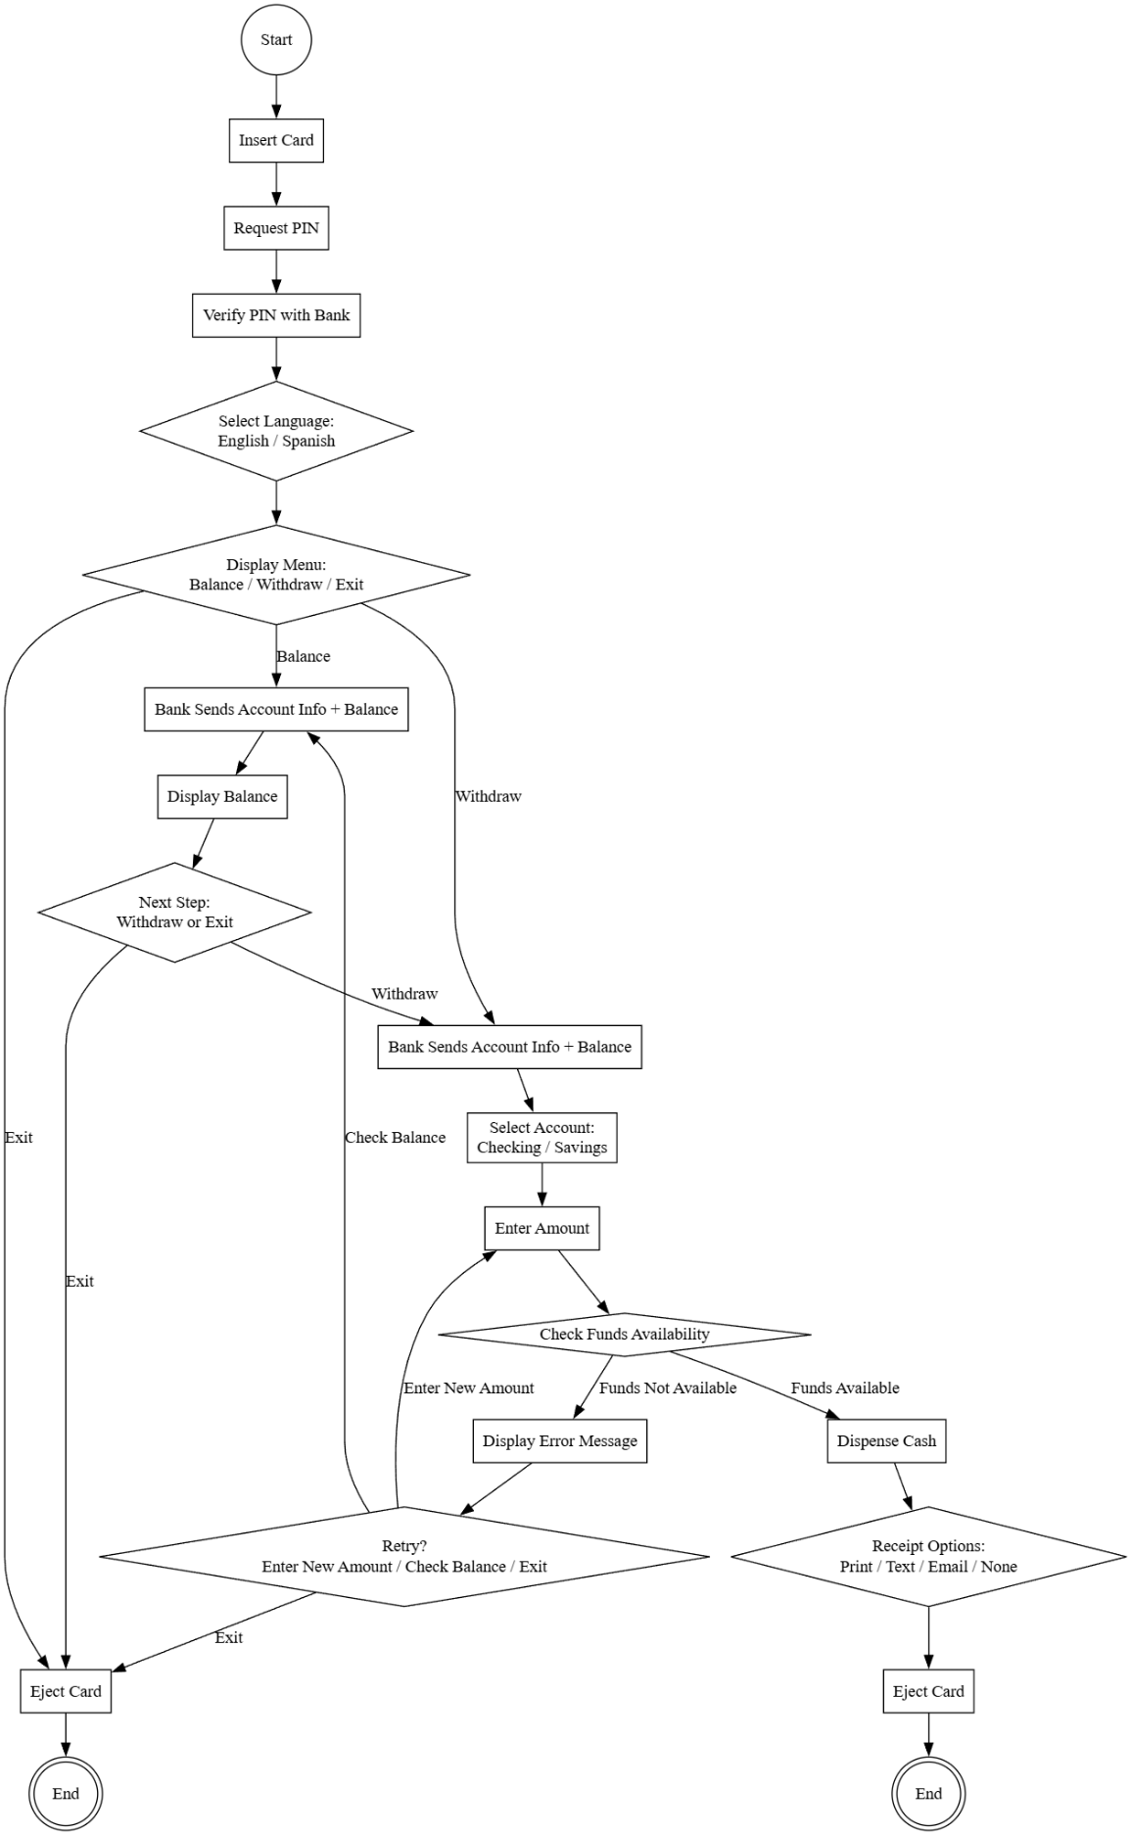
Figure 1Graph made with Graphviz Online

